43.22: (a) 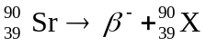
X has 39 protons and 90 protons plus neutrons, so it must be 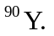
(b) Use base 2 because we know the half life.
